Credit Balance Refund v2
Balance Allocation & Refund from Credit Account
Product Manager : Himanshu Mittal
Business POC : Kizhakkekara GopakumarUmesh Bane

Version History
Version | Author | Date | Details | Approved By | Approval Status
v2 | Himanshu Mittal | 30 May, 2023 | - Allocate Balance  - Transfer from Credit Bal. to GL  - Add fulfillment details | Product  Abhijit BhowmickAshish Patel | Approved
 |  |  |  | Ops  Umesh Bane  Kizhakkekara Gopakumar | Approved
Engg.
Abhishek Bhardwaj
QA
Nagarajan Kuppan

Overview

Current Implementation
Credit Balance Refund is an existing feature in Ops Center, wherein an Ops agent can initiate refund of excess credit balance of end-consumers, present in Allocated & Unallocated buckets of their credit account.
More details of this feature can be found here - OC - Credit Balance Refund

CBR flow
- An AH can have excess balance in his Credit Account in case he has made double Repayment against his credit dues, merchant reversed the amount for which AH has already clear his dues etc
- The Excess balance in AH’s credit account is categorized into 2 buckets:
  - Allocatable Balance
    - Balance in this bucket can be directly adjusted against AH’s purchases
  - Unallocatable Balance
    - Balance in this bucket can’t be used directly, and requires approval by AH for consumption
- In all these scenarios AH is eligible for a refund of excess balance, in which case, Bank would reach out to AH for his confirmation and preferred mode of refund (more details on this step are available Credit Balance Refund1.2.docx for reference)
- AH’s response can have 4 possible scenarios:
  - AH wants refund of excess balance to his personal account (i.e. Savings a/c)
  - AH wants to retain the amount in credit account as usable balance
  - AH doesn’t respond (within 7 days)
    - For ETB AHs: Bank has AH’s account details, so excess bal to be refunded to this account
    - For NTB AHs: Bank doesn’t have AH’s account details, so excess bal from unallocated bucket to be Allocated
  - AH ask for refund after 7 days, when the excess amount in unallocated bucket is already allocated
    - If balance is available in the Allocated\Unallocated bucket, refund from there. Else, Money to be refunded to AH from the Credit Account

Gaps in Current Implementation
- To refund excess bal to AH’s personal account, AH’s personal account details are not captured. So, fulfillment can’t be done
- To retain excess balance, option to allocate unallocated balance is not present
- Capability to refund excess bal from AH’s Credit Account is not available
- Ops agent can potentially specify the incorrect bucket (allocated\unallocated) to refund the amount from, which would be incompliance

Scope
# | Feature | EPIC
1 | Option to allocate the excess balance from Unallocated bucket | EPIC-1
2 | Option to refund the amount from AH’s Credit Account | EPIC-2
3 | Capture the AH’s account details for fulfillment in credit balance refund request from Allocated & Unallocated Balance | EPIC-2
4 | System should maintain the order in which amount should be refunded from various buckets

Key Points
- During credit balance refund, amount would always be refunded from the Unallocated bucket first, then Allocated bucket, and remaining from the Credit Account of AH.
- There are no scenarios in which this sequence would break
- It’s possible that Amount to be refunded could be greater than the combined balance of Allocated, Unallocated & Available Credit Balance. So, there won’t be any validation on max. refund amount on OpsCenter during CBR request creation
  - Validation: Max Credit amount shouldn't be greater than Max Credit Limit
- AH’s consent collection and verification of duplicate requests, will be done by Ops team manually, and will be outside the scope of Ops Center. Ops Center won’t validate duplicacy of refund requests.

Persona
- Business Ops Executive (Maker)
  - About - The L1 person who assists the issuing bank with different operations that are required for providing a good customer experience & maintain compliance
  - Needs - Wants to perform the operations required by bank by initiating the required requests
- Business Ops Manager (Checker)
  - About - The L2 person who manages the ops executive and validates if the executive is working efficiently
  - Needs - Wants to approve/reject the executive’s operations so that the executive doesn’t do any mistakes

Design
[Figma ]

Process Flow

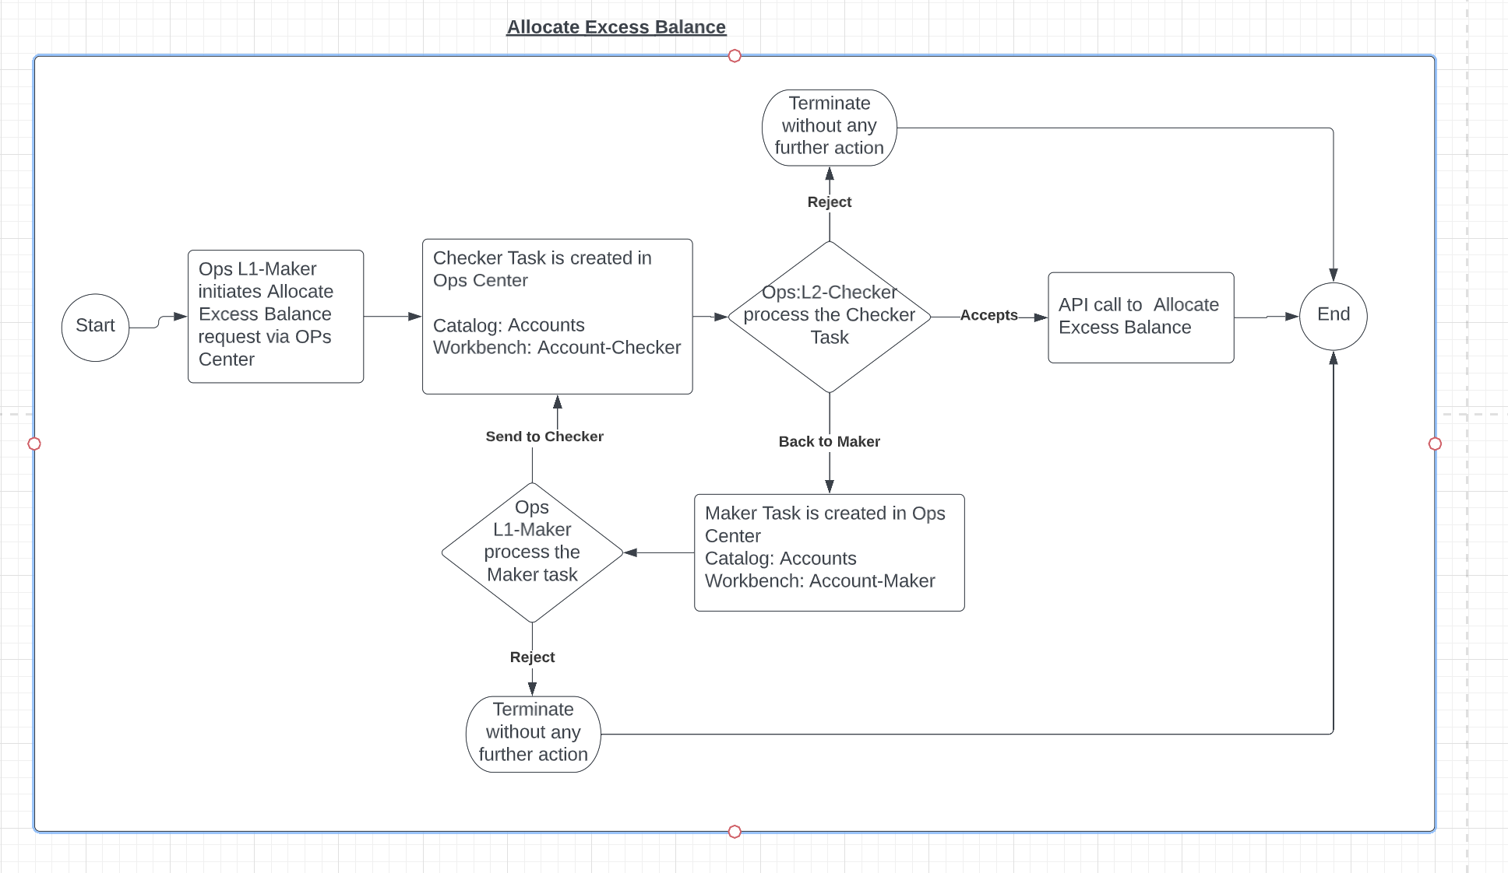
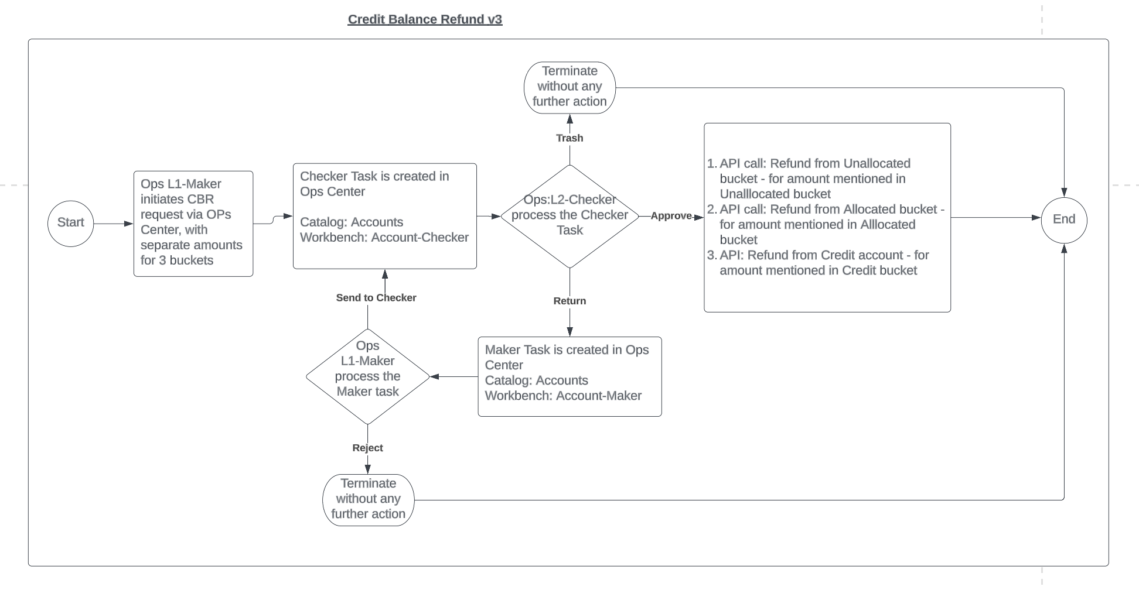
Lucid Link V3

Catalog & WorkBenches
Catalog | Workbench | Persona
Accounts | Accounts-Maker | OPS: L1 Maker
 | Accounts-Checker | OPS: L2 Checker

Acceptance Criteria

[EPIC-1] Allocate Excess Balance - Request

Maker - Request Initiation form
- The agent should be able to find the customer’s account by going to the customer account business component > accounts maker workbench and search a AH’s account
- Inside the credit account, agent should have the option to ‘Allocate Excess Balance’
- On the initiator request form, the agent would be able to
  - View the Current Outstanding Balance of Credit Account
  - View the Allocatable Balance
  - View the Unallocatable Balance
  - View Last Statement Date
  - Enter Value Date
    - Default value will be ‘Last Statement Date’ + 1
    - Note - “Value Date should be ‘Last Statement Date’ + 1”
  - Enter ‘Amount to Allocate’
    - Validation - This should be greater than 0 and less than equal to Unallocatable Balance
  - Select Reason
    - Customer consent
    - Customer account not available
    - Others
  - Maker Remarks
- Once the agent has filled in the requisite information & submit the form and it should create a checker task

Checker Task
- The checker would receive the Allocate Excess Balance task on the Account - Checker workbench task queue
- The task card would have the following attributes
  - Title: Allocate Excess Balance
  - Business Key
  - Account Number
  - Amount
- The task details tab should show all the details captured from Maker task
- The checker can verify the details, add his/her remarks and accordingly Approve, Reject or Send back the task to Maker
  - Checker ‘Approve’ the task
    - API call to allocate excess balance
  - Checker ‘Trash’ the task
    - Close the checker task without any further action
  - Checker ‘Return’
    - Create a Maker task with same details along with Checker Comments
    - Close the checker task

Review Maker Task
- The maker would get the review maker task on queue
- The task card would have the following attributes
  - Title: Allocate Excess Balance
  - Business Key
  - Account Number
  - Amount
- The task details tab should show all the task details along with Checkers comments
- The maker can update details and take below actions:
- Maker Actions:
  - Trash the task
    - Close the Maker task without any further action
  - Update the task
    - Send it to the checker along with updated fields

[EPIC-2] Credit Balance Refund Request

Maker - Request Initiation form
- Below changes are required in the current implementation of Credit Balance Request
  - There should be option for Ops agent to specify the ‘Refund Amount’ separately from below buckets
    - Allocatable Amount
    - Unallocatable Amount
    - Credit Balance
  - ‘Value Date’ field to be added
    - Should be editable field
    - Default value should be set to ‘Current Book Date’ (API)
    - Can’t be any future date
  - Option to select ‘Transfer Mode’ - NEFT \ IFT
  - Option to provide account details:
    - For ‘Transfer Mode’ - NEFT
      - Account Name
      - Account Number
      - IFSC Code
    - For ‘Transfer Mode’ - IFT
      - Account Number
  - Validations:
    - Account Number
      - Should only accept Number values, which can start from ‘0’ as well. Example: 000134 should not become 134
    - IFSC code
      - Can be any alphanumeric value without any special characters
    - Account Name
      - Should only accept alphabets including spaces
    - Allocatable Amount
      - 0 <= Allocatable Amount <= Allocatable Balance
    - Unallocatable Amount
      - 0 <= Unallocatable Amount <= Unallocatable Balance
    - Credit Balance
      - 0 <= Credit Balance <= Credit Limit
  - Error Messages
    - In case of wrong input, User should see the validation error message. Error Message Text:
      - For Allocatable Balance:
        - Amount can’t be less than 0
        - Amount should not be greater than Allocatable Balance
      - For Unallocatable Balance:
        - Amount can’t be less than 0
        - Amount should not be greater than Unallocatable Balance
      - For Credit Balance:
        - Amount can’t be less than 0
        - Amount should not be greater than Max. Credit limit
- Below fields should remain as-is:
  - View Only fields
    - Current outstanding balance
    - Allocated Balance
    - Unallocated Balance
  - Editable fields
    - Remarks
- Validations:
  - Field - ‘Refund Amount’ from Allocatable & Unallocatable
    - Should be a non-negative number value, including ‘0’
    - Can’t be greater than balance in respective buckets
  - Field - ‘Refund Amount’ from Credit Balance
    - Should be a non-negative number value, including ‘0’
    - No validation on the upper limit is required
  - Field - ‘Value Date’
    - Should not a future date
  - All fields (except Remarks) are mandatory
- Once the agent has filled in the requisite information & submit the form and it should create a checker task

Checker Task
- The checker would receive the Credit Balance Refund task on the Account - Checker workbench task queue
- The task card would have the following attributes
  - Title: Credit Balance Refund
  - Business Key
  - Account Number
  - Refund Amount
- The task details tab should show all the details captured from Maker request initiation form
- The checker can verify the details, add his/her remarks and accordingly Approve, Return or Trash the task
  - Checker ‘Approve’ the task
    - Basis the value in field ‘Refund Amount’, the amount has to be refunded from 3 buckets:
      - Unallocated bucket (API)
      - Allocated bucket (Same as above)
      - Credit Account (API)
    - Account details needs to be passed in API as attributes for all below scenarios
      - Unallocated Balance → TL
      - Allocated Balance → TL
      - Credit Balance → TL
  - Checker ‘Trash’ the task
    - Close the checker task without any further action
  - Checker ‘Return’ the task
    - Create a Maker task with same details along with Checker Comments
    - Close the checker task

Review Maker Task
- If Checker ‘Return’ the checker task, Maker Task should be created in Accounts-Maker workbench
- The task card would have the following attributes
  - Title: Credit Balance Refund
  - Business Key
  - Account Number
  - Refund Amount
- The task details tab should show all the task details along with Checkers comments
- Maker should be able to update the details and take below actions:
- Maker Actions:
  - Trash
    - Close the Maker task without any further action
  - Update
    - Send it to the checker along with updated values

Success \ Failure Message
- In case of partial failure post approval, Agent should be informed about the parts which are executed successfully and the remaining failed ones as well
- Example: If amount $1, $2, $3 is to be refunded from Allocated, Unallocated & Credit balance respectively. But, Only $1, $2 is successfully refunded from Allocated, Unallocated, while 3rd API call failed. Then Agent should see below details:
  - $1 refund from Allocated balance - Processed Successfully
  - $2 refund from Unallocated balance - Processed Successfully
  - $3 refund from Credit balance - failed

APIs

API to refund from Allocated \ Unallocated Balance

API (Ruby Solution doc Excess Credit Balance Refund - Solution)
/tenants/{tenantID}/coas/{coaID}/transactionCodes/CC_CREDIT_BALANCE_REFUND/transactions
{
"requestID": "cf7bddfb-2fe6-4d28-be63-34a15068cc36",
"remarks": "Credit Balance Refund",
"ledgerID": "160945919900012", //Debit AH Ledger ID
"payoutFrom": "AllocatableBalance", //Can be AllocatableBalance or UnallocatableBalance (default)
"transactionAmount": {
"currency": "INR",
"amount": 10000
},
"validUntil": 1609459199000,
"bookTime": 1609459199000, //optional, current CBU date will be defaulted if not passed
"valueTime": 1609459199000, //optional, current CBU date will be defaulted if not passed
"attributes": {
"transferMode": "NEFT", //Can be NEFT or IFT
"accountNumber": "557776897878",
"accountName": "John Doe",
"IFSCCode": "ICIC76897878"
}
}

Note:
- "remarks" field value will be “Credit Balance Refund”

API to refund from Credit Account

API
curl --location -g --request POST 'https://ruby.internal.mum1-pp.zetaapps.in/ruby/tenants/{tenantId}/coas/{coaId}/products/{productId}/accounts/{accountId}/debits' \
--header 'Content-Type: application/json' \
--header 'X-Zeta-AuthToken: <token>' \
--header 'Authorization: Bearer <token>' \
--data-raw '{
"value": {
"amount": 9900,
"currency": "INR"
},
"categoryType": "RETAILPRINCIPAL", //this will always be this, hence to be hardcoded
"systemLedgerID": "1815936508987693640", // this is credit ledger to be fetched from ledgerPreferences
"bookTime": 1262329280000,
"valueTime": 1262329280000,
"remarks": "Credit Balance Refund",
"attributes": {
“CBR”:”Y”,
“transferMode”: “NEFT\IFT”,
“accountNumber”:”89786757575778”,
“accountName”:”John Doe”,
“IFSCCode”:”ICICI9978”
},
"requestID": "11318255-e8ac-4a90-b588-c3ea7e325237"
}'

Note:
- “categoryType” will always be “RETAILPRINCIPAL”
- “remarks” will be “Credit Balance Refund”
- “systemLedgerID” needs to be fetched from Ledger Preferences against voucher code = CC_CREDIT_BALANCE_REFUND and component = CREDIT_BALANCE_REFUND; (API: https://ruby.internal.mum1-pp.zetaapps.in/ruby/tenants/140793/products/6083247393995044106)

API to Allocate Excess Balance
Sandboxing details :
- action = "api.tachyon.ruby.account.creditBalanceRefund"
- object: ruby_account
Dev poc: Archit Srivastava

curl --location --request POST 'https://ruby.internal.mum1-pp.zetaapps.in/ruby/tenants/140793/accounts/180b14cc-5843-427b-bafe-a5f9e244bcee/allocateBalance' \
--header 'X-Zeta-AuthToken: <authToken>' \
--header 'Content-Type: application/json' \
--data-raw '{
"requestID": "cf7bddfb-4fe6-5d28-be65-38a15070cc39",
"remarks": "Allocate unallocated excess credit balance",
"transferAmount": {
"currency": "USD",
"amount": 1000
},
"valueTime": 1609459199000, //optional, current CBU date will be defaulted if not passed
"attributes": {
“reason”:”Customer Consent”
}
}'

Aura API (Ruby solution doc Excess Credit Balance Refund - Solution)
API Dev poc : Shubham
Sandboxing details :
Fluent API sandbox details
action:- api.journal.fluentRecordTransaction
object:- voucher code which is being used

/tenants/{tenantID}/coas/{coaID}/transactionCodes/CC_ALLOCATE_BALANCE/transactions
{
"requestID": "cf7bddfb-2fe6-4d28-be63-34a15068cc36",
"remarks": "Allocate excess credit balance",
"ledgerID": "160945919900012", //Debit AH Ledger ID
"transferAmount": {
"currency": "INR",
"amount": 10000
},
"validUntil": 1609459199000,
"bookTime": 1609459199000, //optional, current CBU date will be defaulted if not passed
"valueTime": 1609459199000, //optional, current CBU date will be defaulted if not passed
"attributes": {
}
}

Note:
- “Remarks” field will be “Allocate unallocated excess credit balance”

API to get Current Book date

curl 'https://aura.internal.mum1-pp.zetaapps.in/coa/tenants/151613/coas/1519979782001682225/currentCBU?clockType=BOOK' \
-H 'Accept: application/json, text/plain, */*' \
-H 'Accept-Language: en-GB,en;q=0.9' \
-H 'Authorization: <token>' \
-H 'Cache-Control: no-cache' \
-H 'Connection: keep-alive' \
-H 'DNT: 1' \
-H 'Origin: https://turbohdfc-sc0hercules.mum1-pp.zetaapps.in' \
-H 'Pragma: no-cache' \
-H 'Sec-Fetch-Dest: empty' \
-H 'Sec-Fetch-Mode: cors' \
-H 'Sec-Fetch-Site: same-site' \
-H 'User-Agent: Mozilla/5.0 (Macintosh; Intel Mac OS X 10_15_7) AppleWebKit/537.36 (KHTML, like Gecko) Chrome/110.0.0.0 Safari/537.36' \
-H 'sec-ch-ua: "Chromium";v="110", "Not A(Brand";v="24", "Google Chrome";v="110"' \
-H 'sec-ch-ua-mobile: ?0' \
-H 'sec-ch-ua-platform: "macOS"' \
--compressed

Sample Response
{
"id": 2101553846868233500,
"tenantID": "151613",
"startCbuSequenceNumber": 1,
"calendarID": 1145061067624296100,
"clockID": 2711081297789624000,
"cycle": {
"id": 7570509263008874000,
"clockID": 2711081297789624000,
"startCbuSequenceNumber": 1,
"calendarID": 1145061067624296100,
"periodicity": "DAILY",
"name": null,
"description": null,
"code": "CLO00001_CBU",
"attributes": null
},
"endCbuSequenceNumber": 1,
"sequenceNumber": 1,
"attributes": null,
"startTime": 1585679400000,
"nextPeriodStartTime": 1585765800000,
"formattedStartTime": "2020-04-01T00:00+05:30[Asia/Kolkata]",
"formattedNextPeriodStartTime": "2020-04-02T00:00+05:30[Asia/Kolkata]",
"status": "BOFI",
"transitionMap": null
}

NFRs
OC | NFRs

References

- BRD - OAK428 - Credit Balance Refund
- Business SPOC - Gopakumar Kizhakkekara
- Ruby : PRD - RBI MD: Card Lifecycle and Card Closure
- Scope discussion
- CBR PRD v1: OC - Credit Balance Refund
- CBR SOP: Credit Balance Refund1.2.docx
- CBR SOP steps: CBR - SOP
- Jira: https://zeta-tm.atlassian.net/browse/TCH-8761

